36U ENCLOSURE 19" CABINET 600X600 FLOOR STANDING DATA RACK - ECO NETCAB
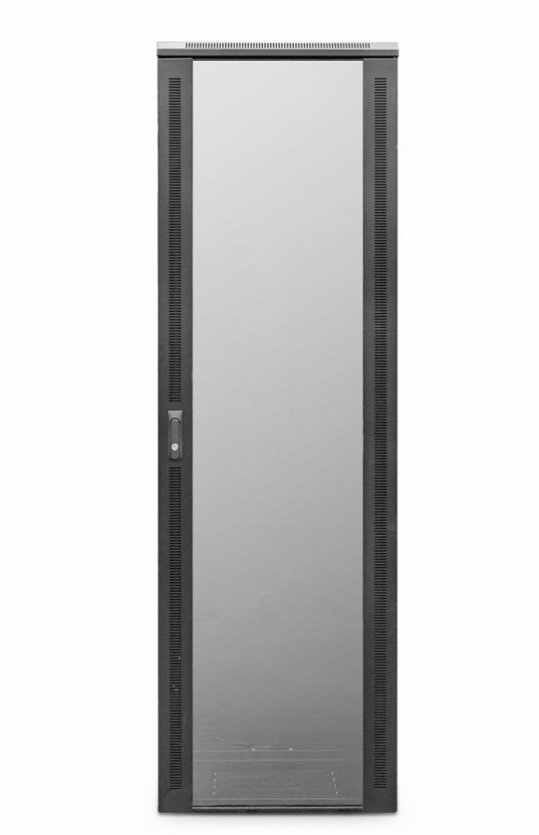

DESCRIPTION
Quality Assembled , Competitively Priced
Need a well priced but quality built data and telecoms cabinet for your installation or project?
With the assurance of the product line being expertly assembled in the UK to
the same attention of the rest of the LMS Data EcoNetCab range, the ValuCabs
offer all the cabinet functionality you’ve come to expect from LMS Data including
adjustable 19-inch uprights, remove sidepanels, front and rear (reversible) lockable
doors and a multitude of cable entry areas.
Ideal for telecom, networking and mixed media applications including CCTV,
broadcast and other data applications, the ValuCab range starts at just 18U, right up
to 42U for larger installations. A choice of standard 600mm and 800mm wide (free
cable management on the 800mm version) and a choice of either industry-standard
600mm deep, or deeper 800mm for larger equipment deployments.

SPECIFICATIONS
36U high 600W 600D
ETSI 19” front/rear profiles, adjustable
Lockable vented glass door, reversible
Removable side panels, rear lockable door
Ideal for Networking, Broadcast & PBX
Supplied with Castors and Jacking Feet
UK Assembled and quality assured

TECHNICAL INFO
SKU/MPN: CAB-FE-36U-66
EAN: CAB-FE-36U-66
Weight: 100.0Kg
Dimensions: 600(width) x600(depth) x1780mm(height)

FILES
Datasheet - CAB-FE-36U-66

